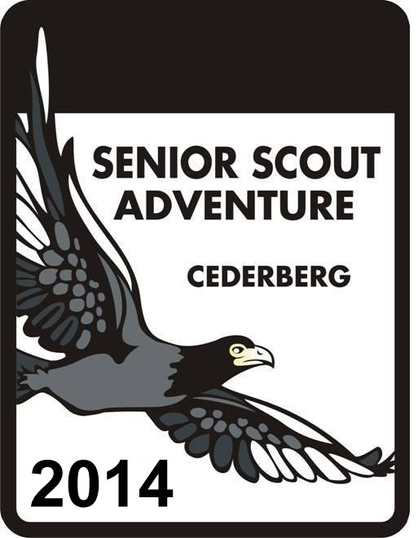
21st Senior Scout Adventure
12 - 23 December 2014

Mountain Ranger Application

This form is to be completed by all persons applying for the role of Mountain Ranger.

This is a specialised Staff position and requires the form to be completed in full detailing your experience, capabilities and where applicable all the necessary approvals.

Please return this form to the Adventure Secretary (adventure@scouting.org.za) for your application to be assessed by the organisers.
FIRST NAME AND SURNAME
TECHNICAL SKILLS (Circle option where appropriate)
Are you fit enough to ascend 1000m in one day with full overnight kit starting at 5:30am in December in the Cederberg? | Yes, Maybe, No
State your level of First Aid competency. | Excellent, Good, Fair, Poor, Useless
Can you read a 1:50000 topographical map? | Yes, Maybe, No
On the 1:50000 map how many centimetres = 1km? | 1cm, 2cm, 3cm, 4cm, 5cm
Can you use a magnetic compass, back-bearings and triangulation to find your position on a 1:50000 topographical map? | Yes, Maybe, No
Given the Cederberg mountains and the many good land marks, how accurately can you plot your position on the 1:50000 topographical map without using a compass or GPS? | 10m, 100m 200m, 500m, >=1km
Can you use a GPS? If so, what type of GPS? | Yes, Maybe, No
How accurate do the current range of GPS's (under R5000.00) state your latitude and longitude. | 0.5m, 1m, 2m, 5m, 50m.
EXPERIENCE
List the mountains hiked/climbed with approximate dates in the last 2 years.

Document the routes you have hiked in the last 6 months. A precise and concise description is required.
eg. Day 1: Welbedacht Kloof, Jeep Track, Engelsmanskloof, Crystal Pool. Day 2: Crystal Pool, Groot Hartseer, Uilsgat Needles, Middelberg Hut, Algeria

YOUR PREFERENCES (Circle option where appropriate)
Do you prefer to  - Roam the mountains assisting many patrols or  - Hike with a single Patrol for the duration of the Adventure or  - Provide logistical support by driving YOUR own vehicle. | A  B  C
Are you willing to be assigned to a patrol that is not your “home” Patrol? | Yes, No
Are you willing to undergo a training session on the roles and responsibilities of the Mountain Ranger before the Adventure starts (date and venue to be advised). | Yes, No
Are you willing to abide by the SA Scouting Outdoor Code? | Yes, No
Are you willing to be a role model and in so doing encourage others in the Patrol to uphold a high standard of ethics and morals? | Yes, No
There are on rare occasions, times when Patrol dynamics may become a little stressed.  Are you able to see both points of view and mediate? | Yes, Maybe, No
Have you ever lead a Patrol of Scouts before? | Yes, No
With the change in Patrol Composition and Mountain Ranger strategy for 2012, it is envisaged that not all Patrols will have a Patrol Leader (who is approved by the Adventure). Would you be willing to lead such a Patrol? | Yes, No
Supply two references of people who can attest to your mapping, hiking and people skills.

Reference 1: First name Surname Cell Phone Number

Reference 2: First name Surname Cell Phone Number

What do you consider your tasks would be as a Mountain Ranger?
1.
2.
3.
4.
5.
6.

RECOMMENDATIONS, APPROVALS AND APPLICANTS SIGNATURES
WARRANTED SCOUTERS (Including Permit holders)

RECOMMENDED BY _____________________________________________ DATE ___________________
(Must be a Warranted Scouter - Please print full Names and Rank)

APPROVED BY DISTRICT COMMISSIONER /
PROVINCIAL COMMISSIONER__________________________________ DATE __________________

SIGNATURE OF APPLICANT: _____________________________________ DATE: __________________

NON SCOUT WARRANT HOLDERS

Before signing this Staff application form, the applicant must accept and understand the following conditions of participating in the Senior Scout Adventure:

I accept that the Aim of The Scout Association is to promote the development of young people in achieving their full physical, intellectual, social and spiritual potentials, as individuals, as responsible citizens and as members of their local, national and international communities.

I accept and understand that the Child Protection Policy (www.scouting.org.za/library/por/ChildProtectionPolicy.pdf) of The Scout Association is to safeguard the welfare of all members by protecting them from physical, sexual and emotional harm.

I understand that my voluntary work for the Scout Association may involve substantial contact with persons under the age of 18 years of age and that any conviction involving minors which would be regarded as "spent" for other purposes must be hereby disclosed.

I declare that I do not have a criminal record by having been found guilty by court of law. Additionally I have not been suspended or censured for any action concerning children, young people, sexual misconduct or related offences.

I am not, to the best of my knowledge, the subject of any criminal investigation or awaiting the outcome of proceedings against me before a criminal court or other tribunal.

I undertake to report to the District Commissioner/Provincial Commissioner or Chief Scout’s Commissioner, as appropriate, any changes in my circumstances that could affect my role.

RECOMMENDED BY ____________________________________________________ DATE ___________________
(Must be a Warranted Scouter - Please print full Names and Rank)

APPROVED BY DISTRICT COMMISSIONER /
PROVINCIAL COMMISSIONER__________________________________ DATE __________________

SIGNATURE OF APPLICANT ____________________________________________ DATE __________________

